Exe 1

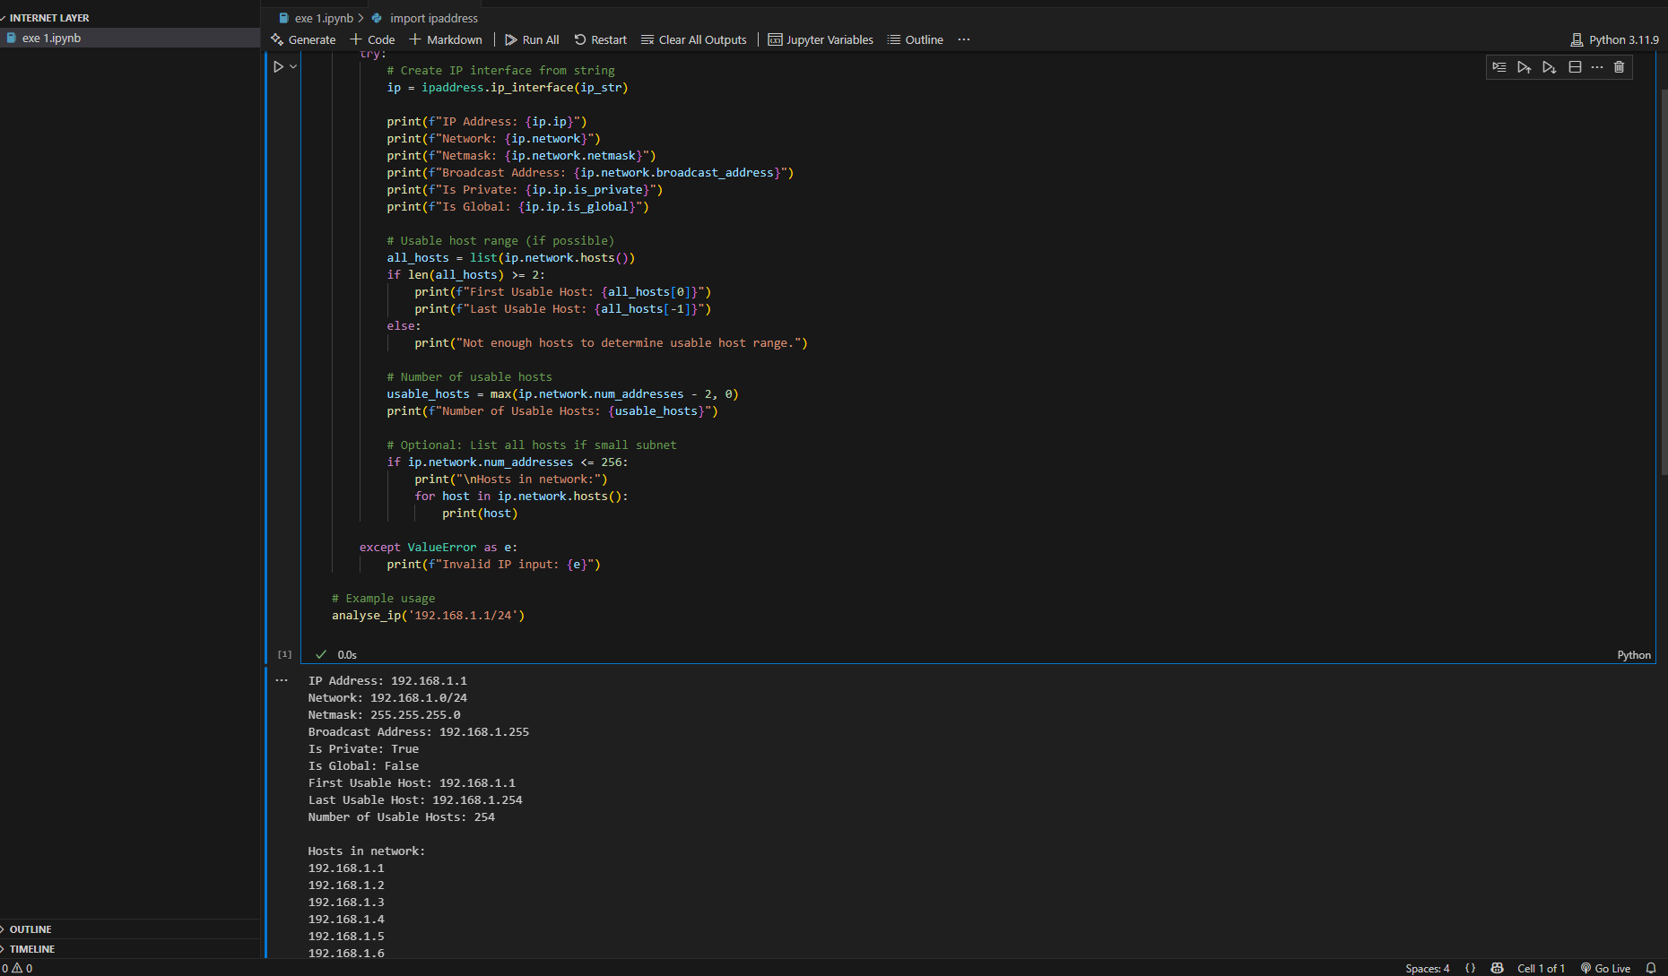

Exe 2

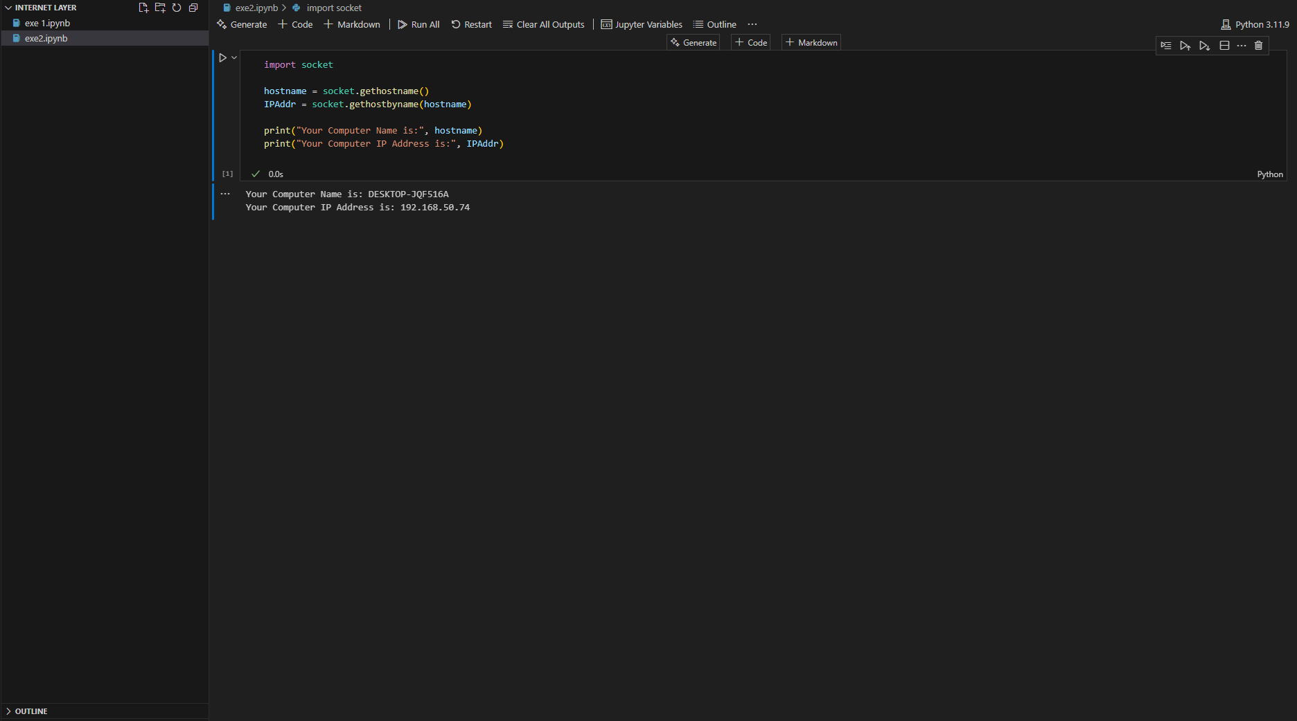

Exe 3

Exe 4

Exe 5

